**PERFORMANCE REPORT**

**After running each test you have to repopulate the database .**

All the performance test has been executed in the Developer VM with the next configuration:

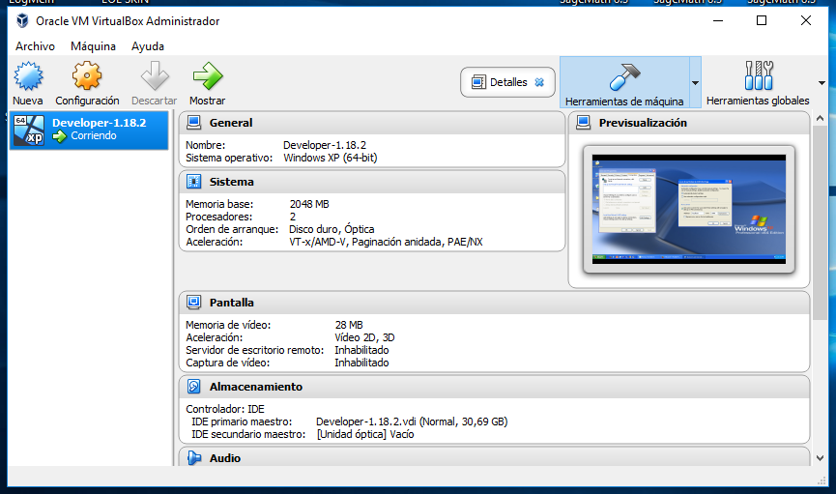

We have to set the proxy configuration as the following picture to run the test in the Developer VM:

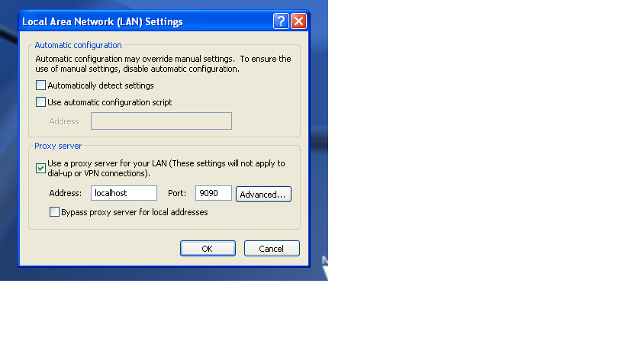

# Table of contents

Table of contents 2

UC29.1 Register reader test 4

UC29.1 Register organizer test 5

UC35.12 Register referee test 6

UC29.1 Register sponsor test 7

UC35.1 Register administrator test 8

UC30.2 Edit administrator test 9

UC30.2 Edit organizer test 10

UC30.2 Edit reader test 11

UC30.2 Edit referee test 12

UC30.2 Edit sponsor test 13

UC30.3 Manage Social Profiles Test 14

UC30.4 Manage Messages test 15

UC30.5 Manage Messages Boxes test 16

UC31.1 Manage Books test 17

UC31.2 Buy Sale Test 18

UC31.2 Create Exchange test 19

UC31.2 Offer test 20

UC31.3 Cleaning Finder test 21

UC31.3 Updating Finder test 22

UC31.4 Complaint test 23

UC31.4 Comment test 24

UC32.1 Manage Event test 25

Register Event test 26

UC33.1 Manage Sponsorships test 27

UC34.1,UC34.2,UC34.3 Report test 28

UC35.2 Manage Category test 29

UC35.3 Broadcast test 30

UC35.5, UC35.6 Ban Unban Actor test 31

UC35.7 Add Negative Word test 32

UC35.7 Add Positive Word test 33

UC35.7 Delete Positive Word test 34

UC35.7 Delete Negative Word test 35

UC35.8 Deactivate Sponsorships test 36

UC35.9 Delete Inactive Books test 37

UC35.10 Calculate Spam test 38

UC35.13 DashBoard test 39

UC35.11 Calculate Score test 40

# UC29.1 Register reader test

Aggregate Report

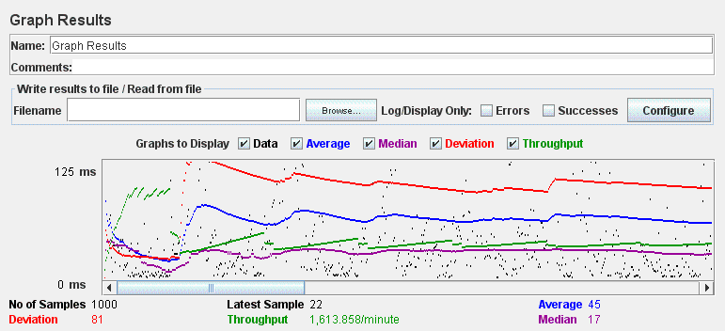

Graph Result

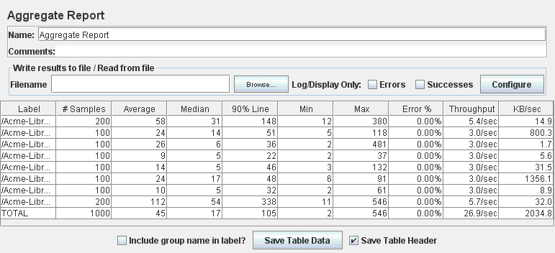

# UC29.1 Register organizer test

Aggregate Report

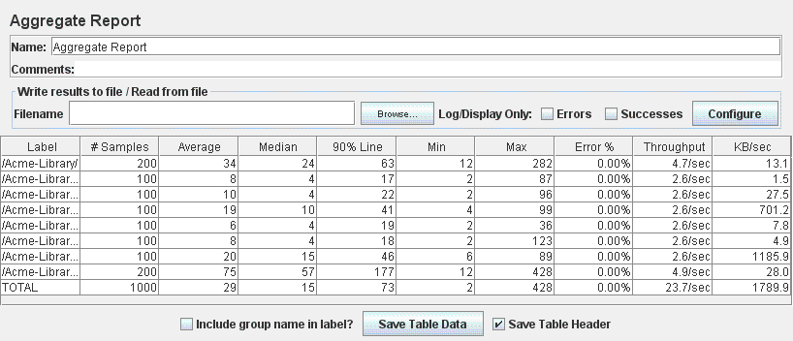

Graph Result

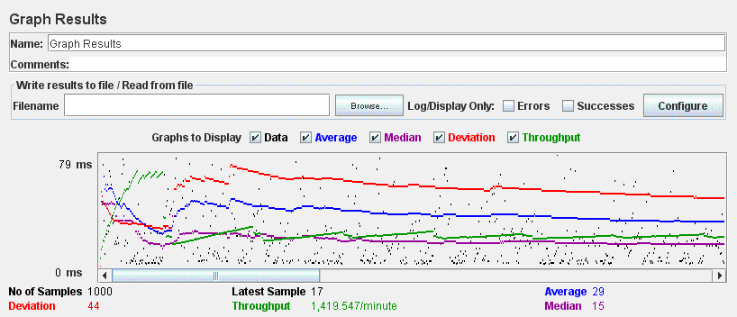

# UC35.12 Register referee test

Aggregate Report

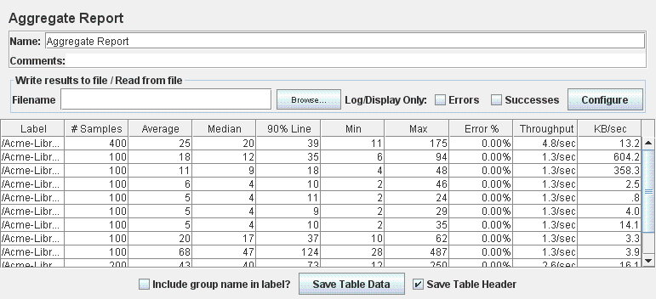

Graph Result

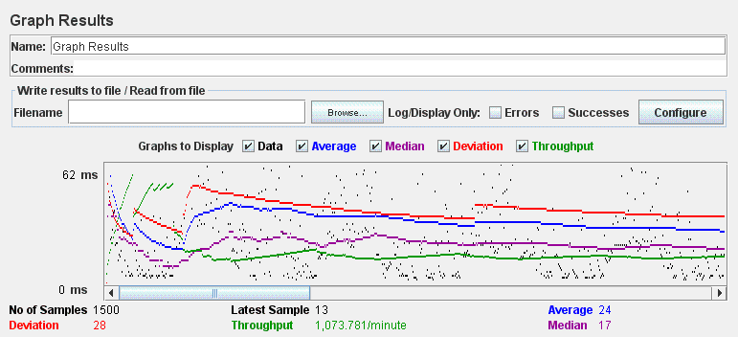

# UC29.1 Register sponsor test

Aggregate Report

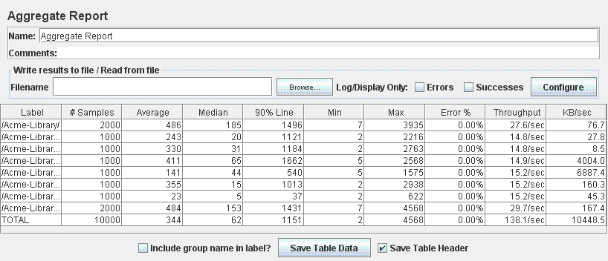

Graph Result

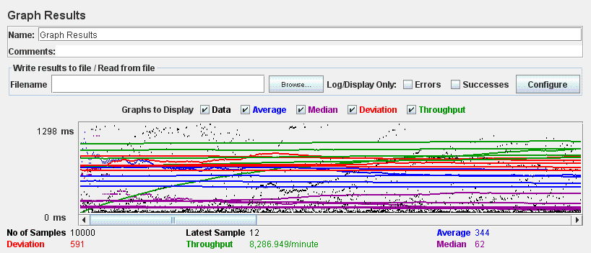

# UC35.1 Register administrator test

Aggregate Report

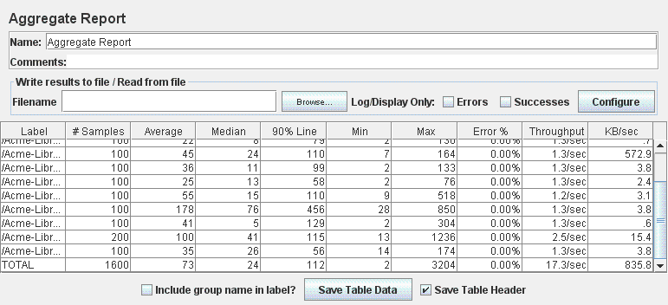

Graph Result

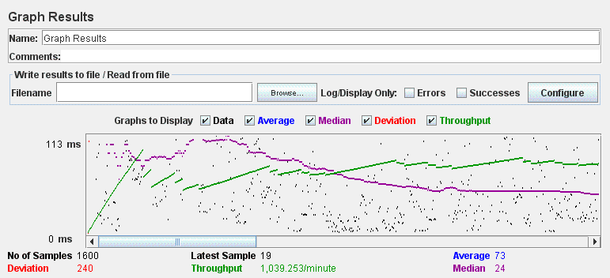

# 

# UC30.2 Edit administrator test

Aggregate Report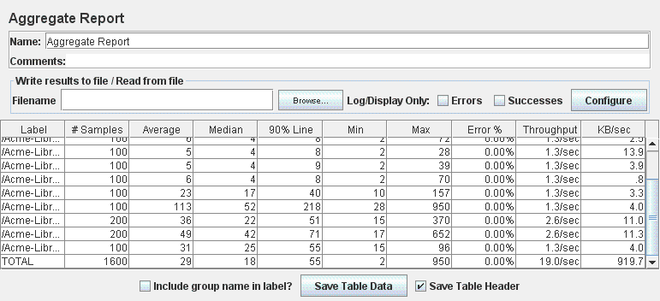

Graph Result

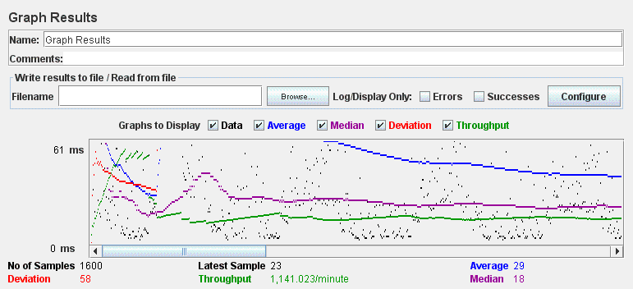

# UC30.2 Edit organizer test

Aggregate Report

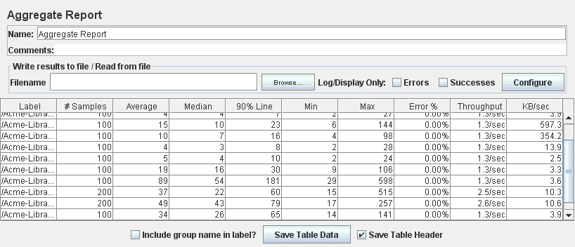

Graph Result

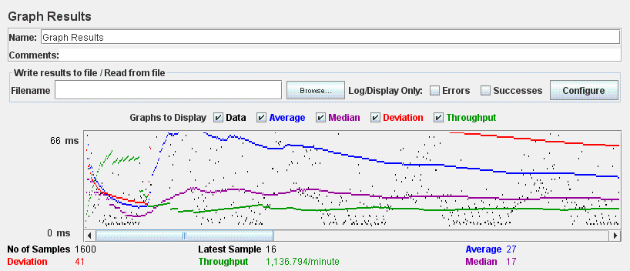

# UC30.2 Edit reader test

Aggregate Report

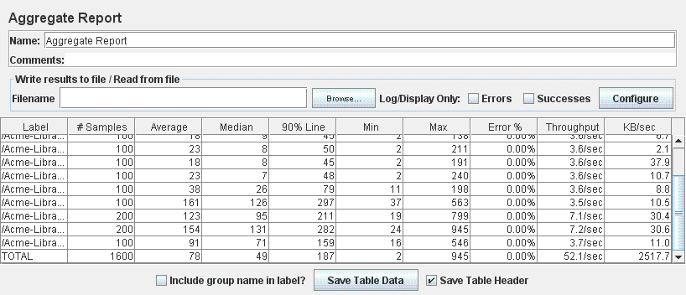

Graph Result

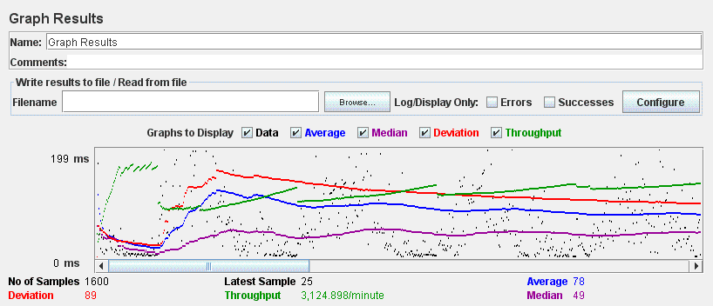

# UC30.2 Edit referee test

Aggregate Report

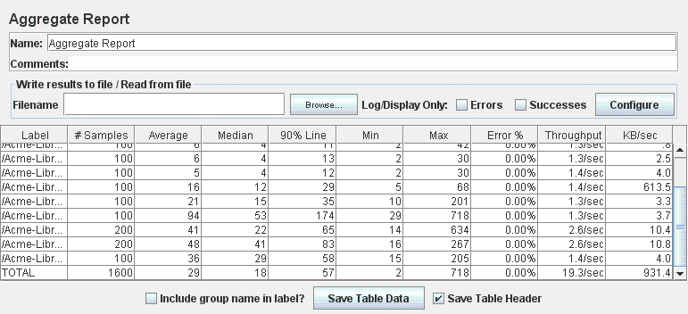

Graph Result

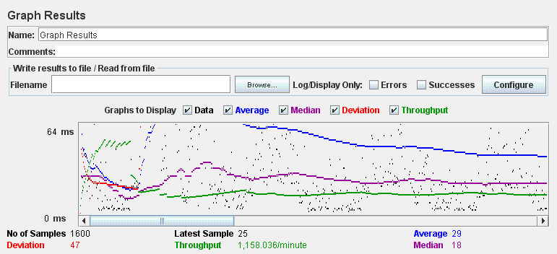

# UC30.2 Edit sponsor test

Aggregate Report

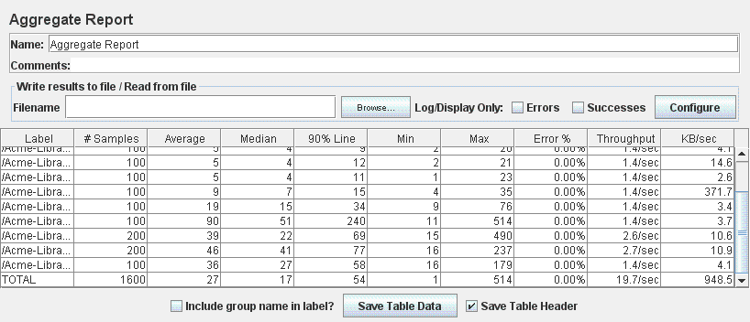

Graph Result

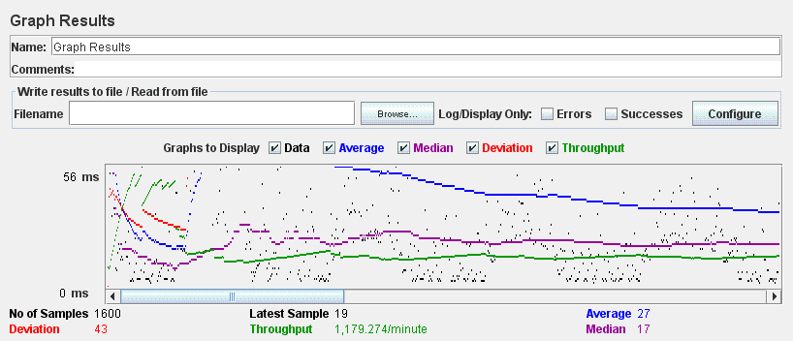

# UC30.3 Manage Social Profiles Test

Aggregate Report

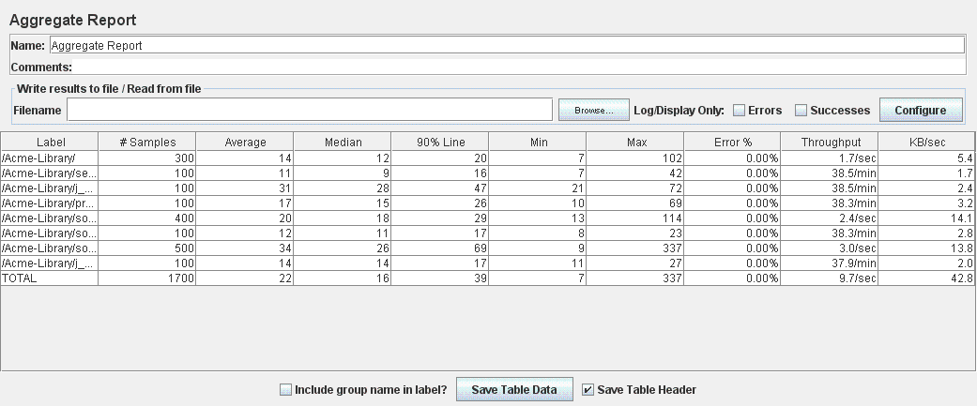

Graph Result

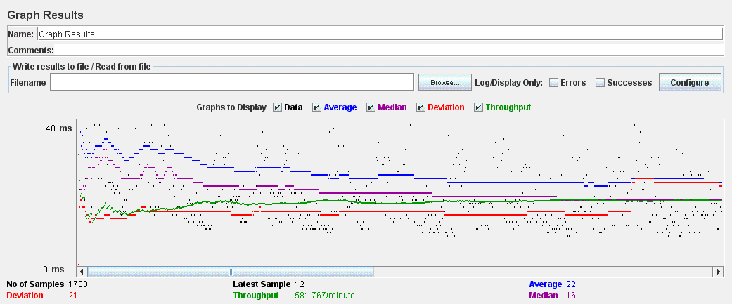

# UC30.4 Manage Messages test

Aggregate Report

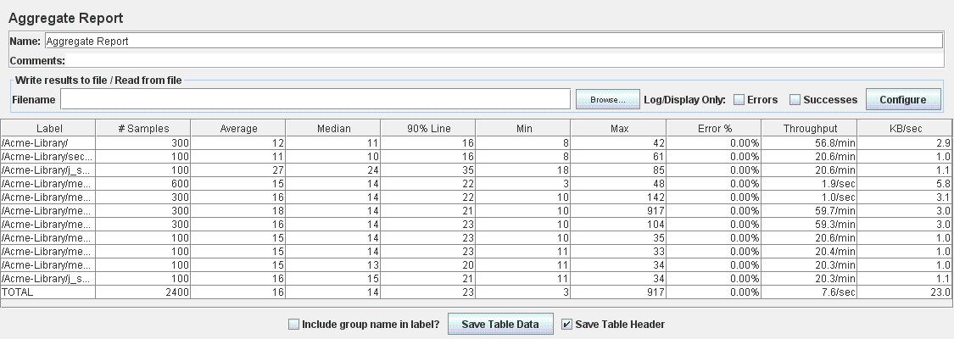

Graph Result

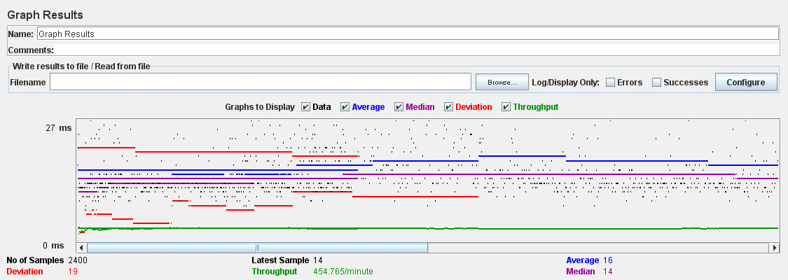

# UC30.5 Manage Messages Boxes test

Aggregate Report

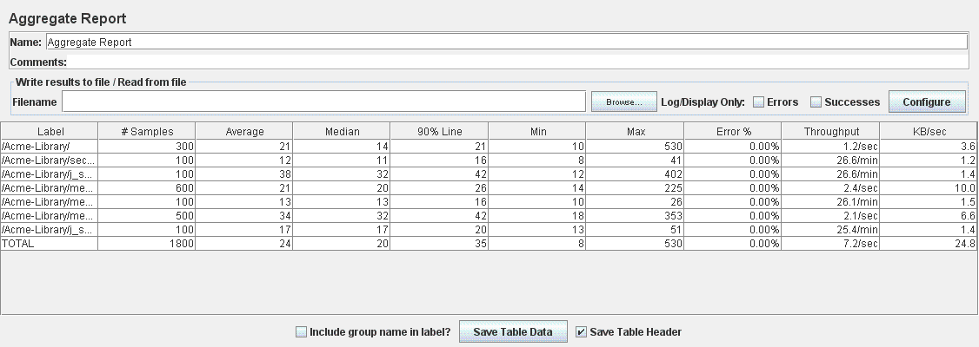

Graph Result

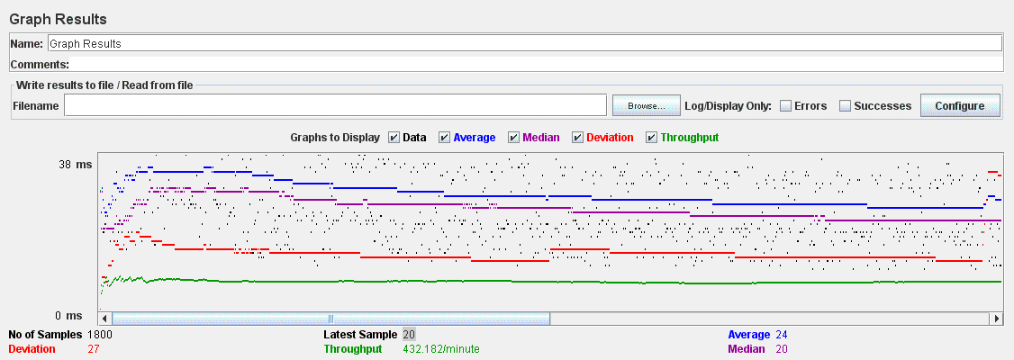

# UC31.1 Manage Books test

Aggregate Report

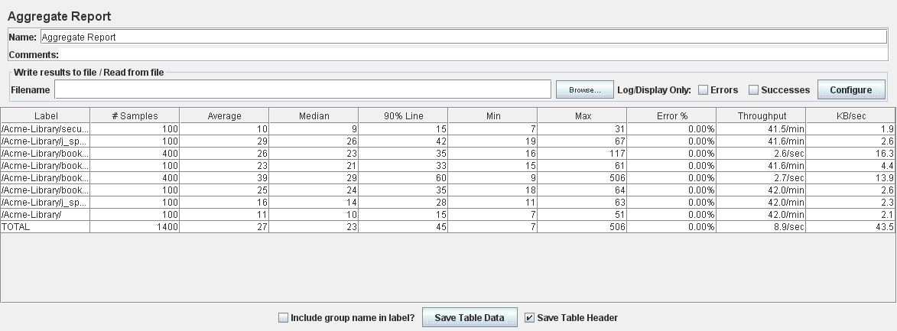

Graph Result

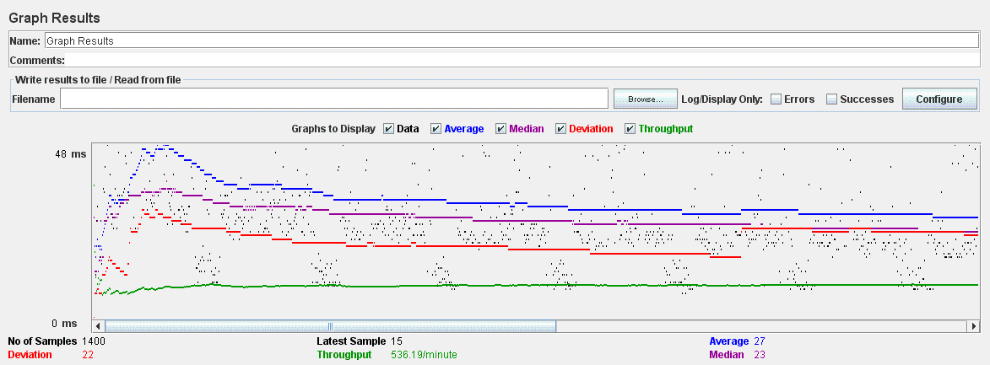

# UC31.2 Buy Sale Test

Aggregate Report

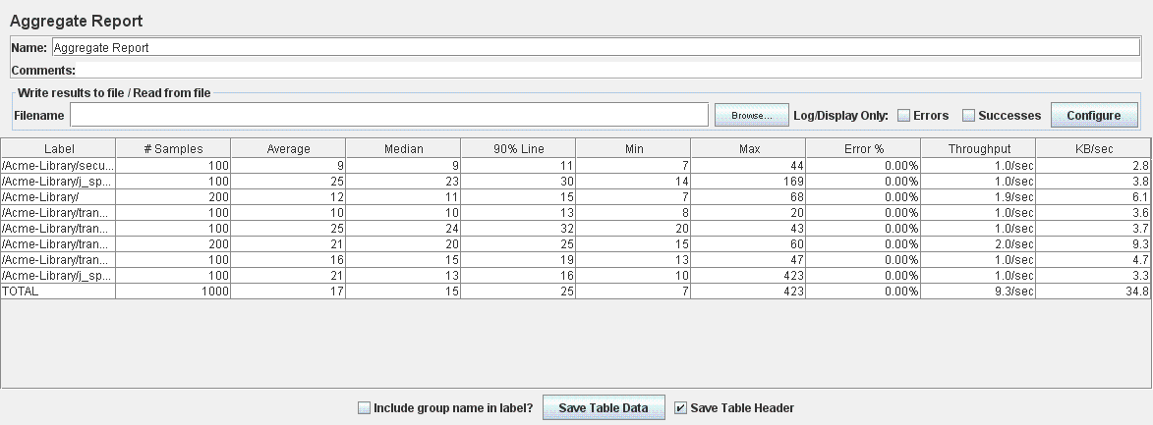

Graph Result

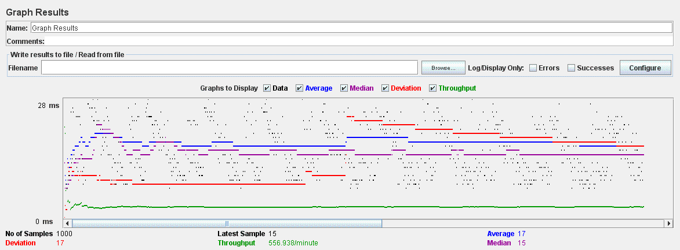

# UC31.2 Create Exchange test

Aggregate Report

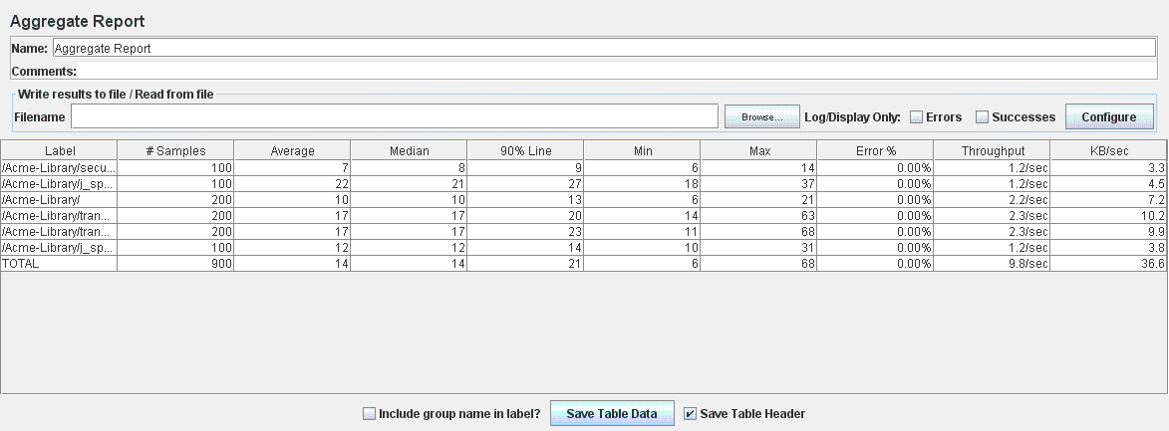

Graph Result

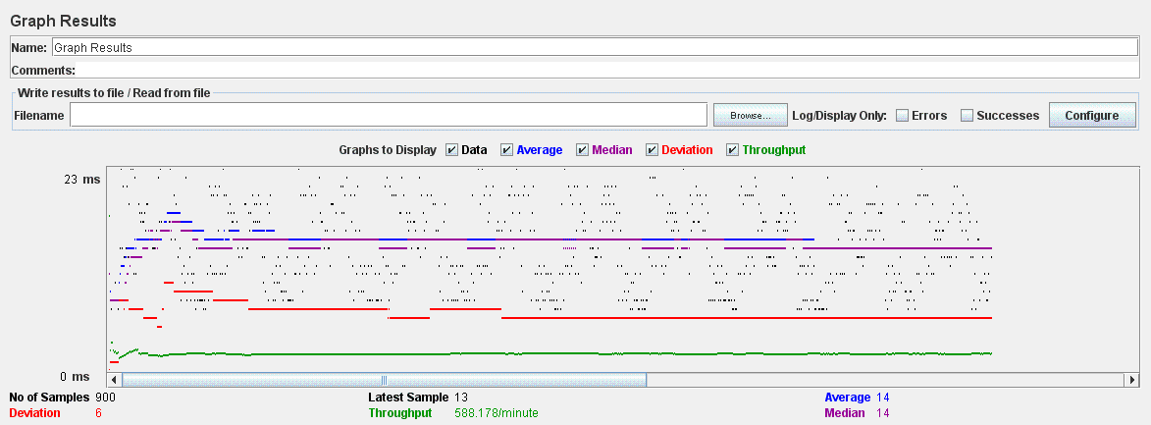

# UC31.2 Offer test

Aggregate Report

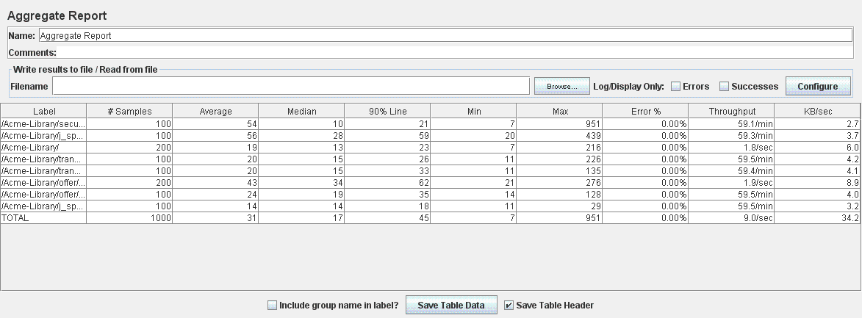

Graph Result

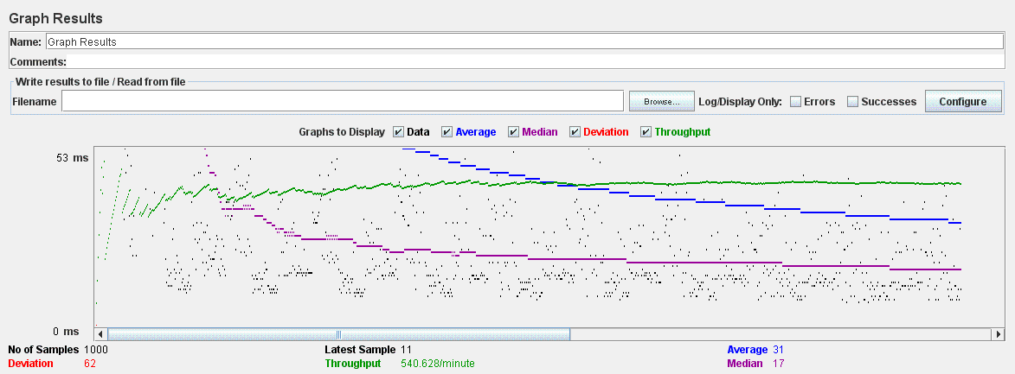

# UC31.3 Cleaning Finder test

Aggregate Report

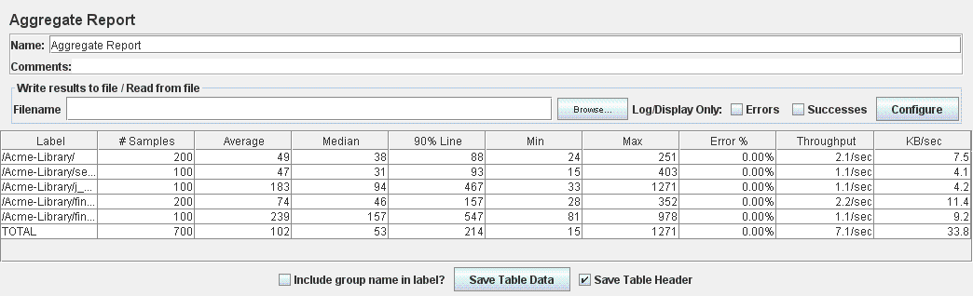

Graph Result

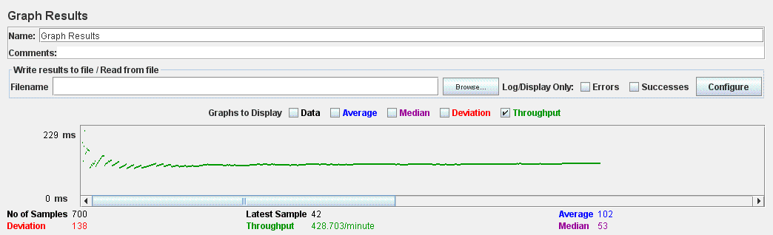

# UC31.3 Updating Finder test

Aggregate Report

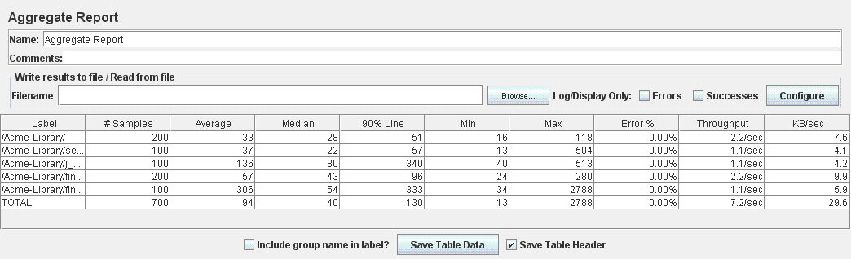

Graph Result

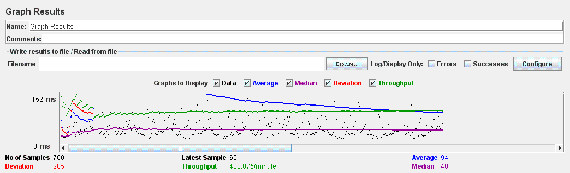

# UC31.4 Complaint test

Aggregate Report

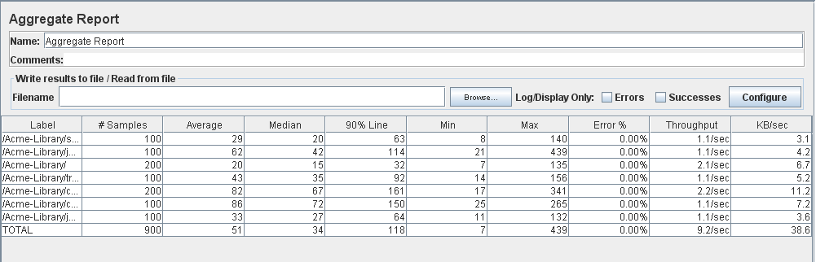

Graph Result

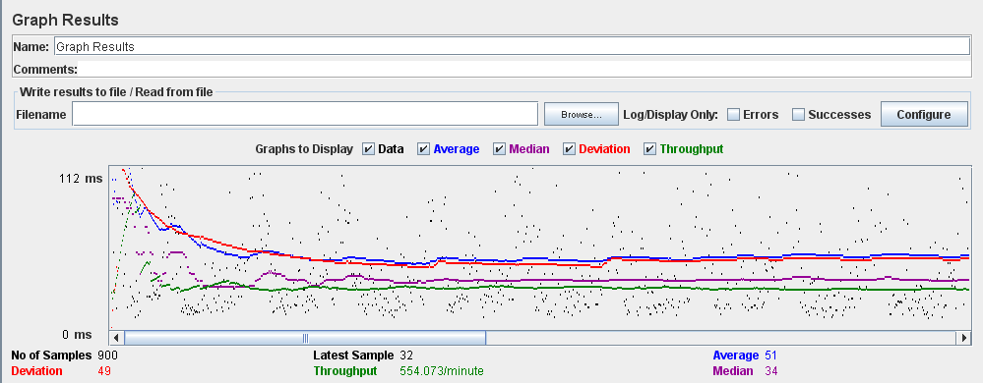

# UC31.4 Comment test

Aggregate Report

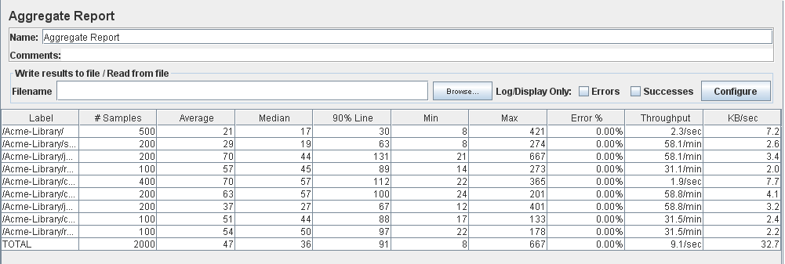

Graph Result

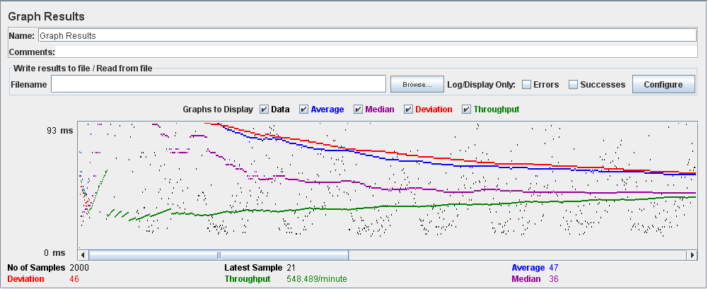

# UC32.1 Manage Event test

Aggregate Report

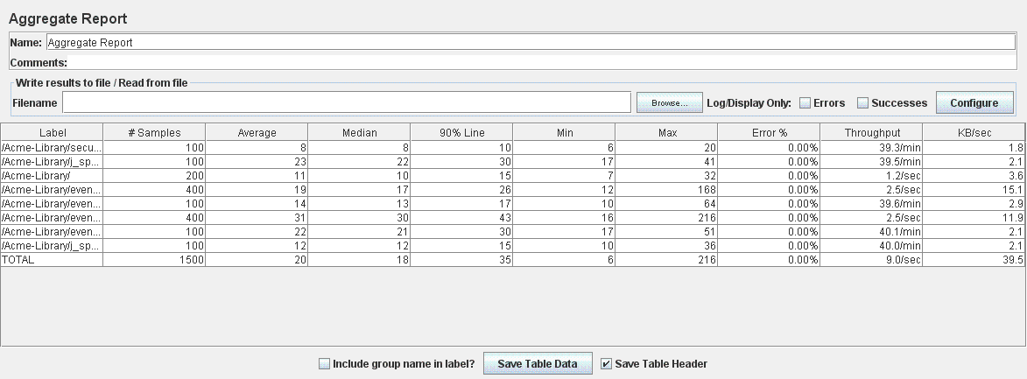

Graph Result

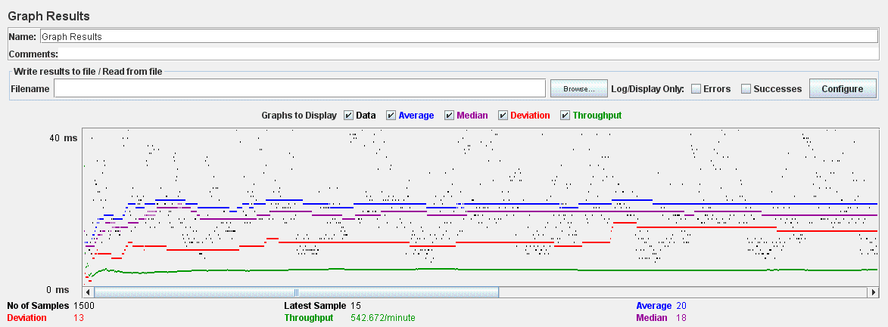

# Register Event test

Aggregate Report

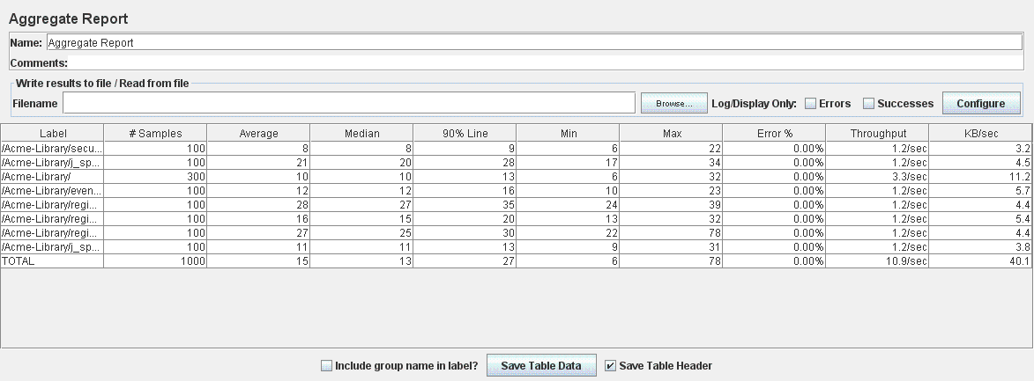

Graph Result

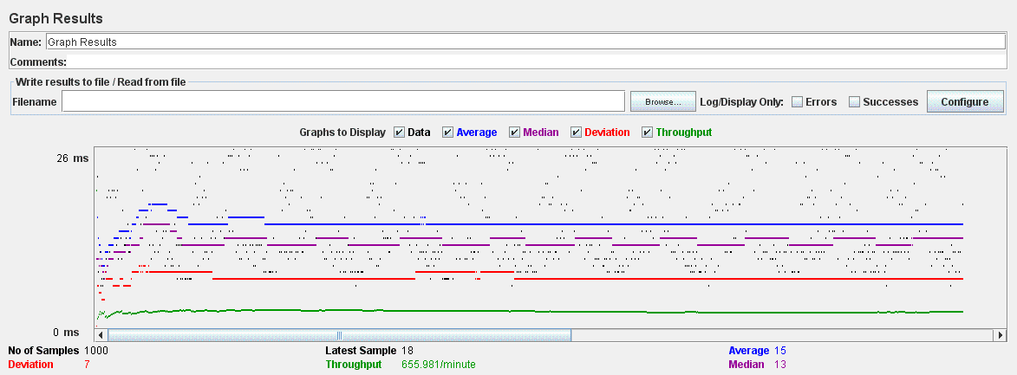

# UC33.1 Manage Sponsorships test

Aggregate Report

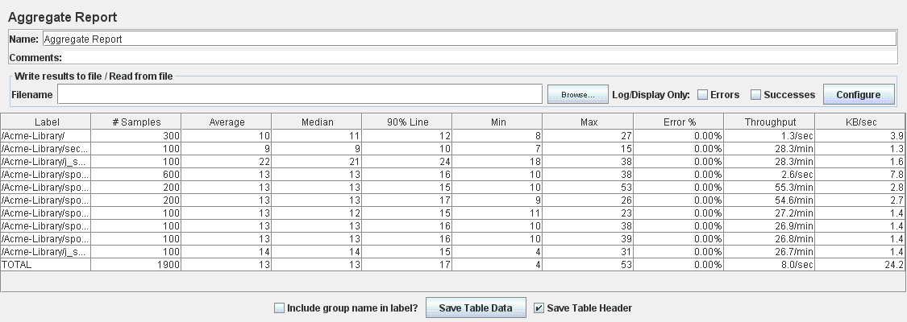

Graph Result

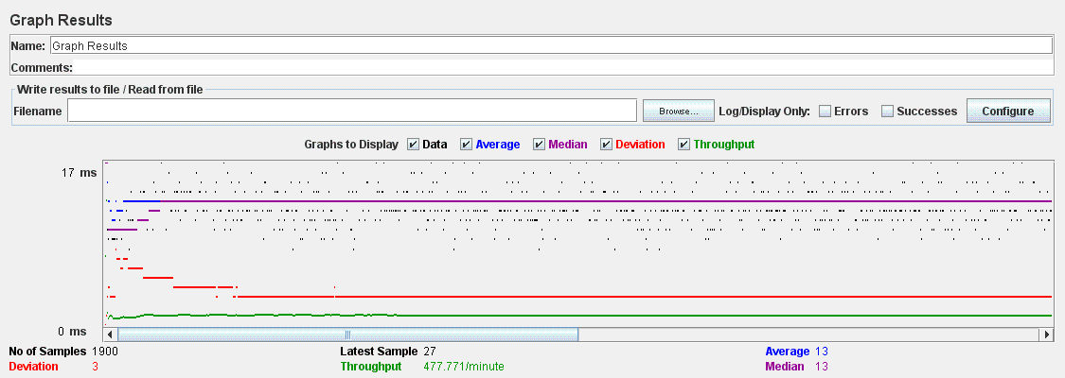

# UC34.1,UC34.2,UC34.3 Report test

Aggregate Report

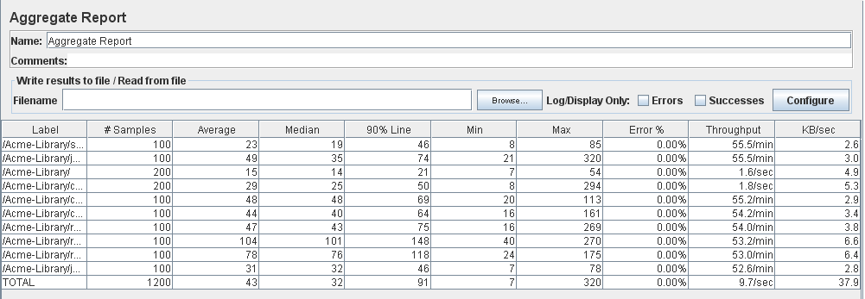

Graph Result

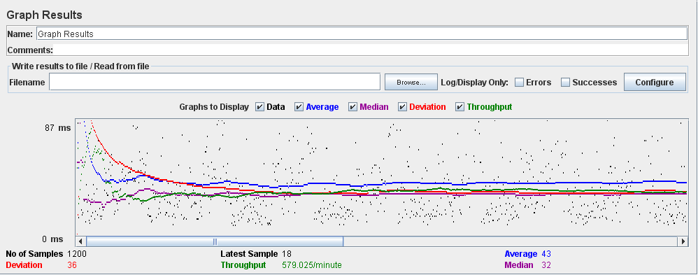

# UC35.2 Manage Category test

Aggregate Report

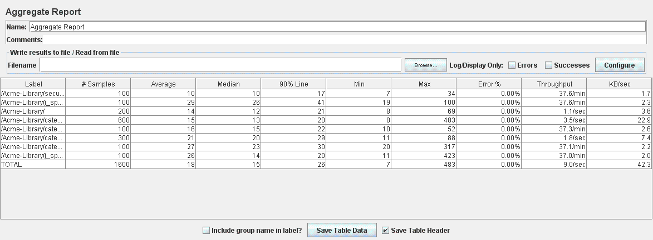

Graph Result

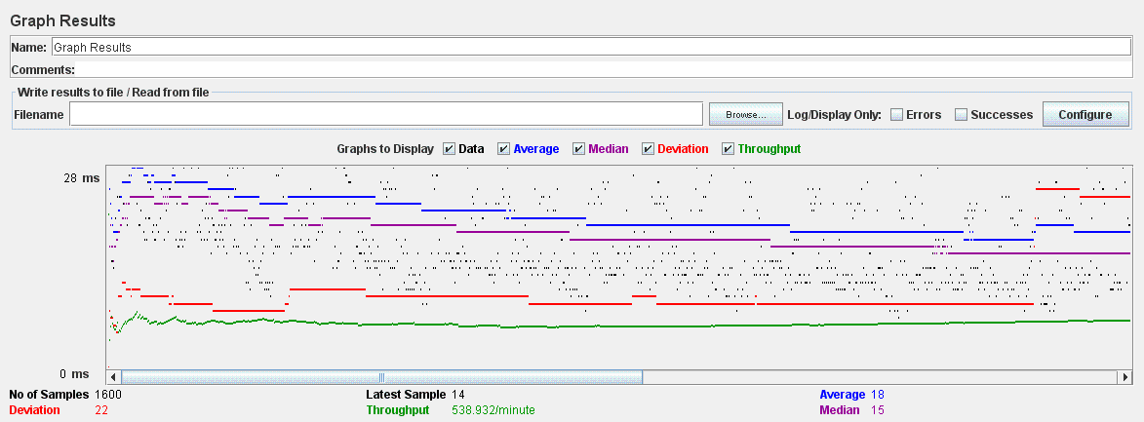

# UC35.3 Broadcast test

Aggregate Report

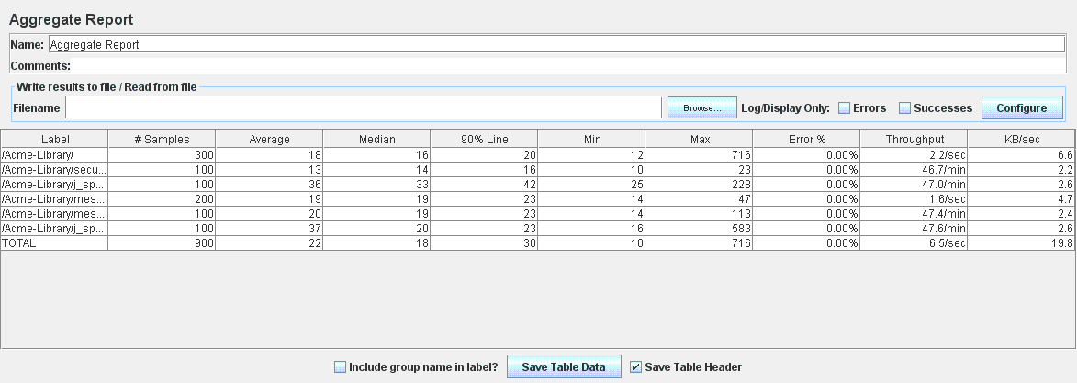

Graph Result

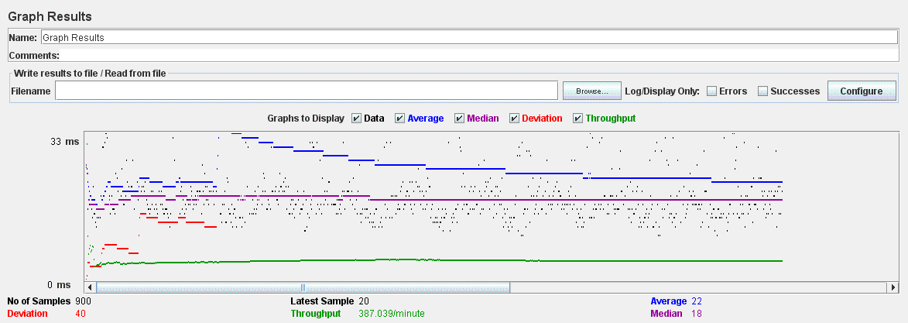

# UC35.5, UC35.6 Ban Unban Actor test

Aggregate Report

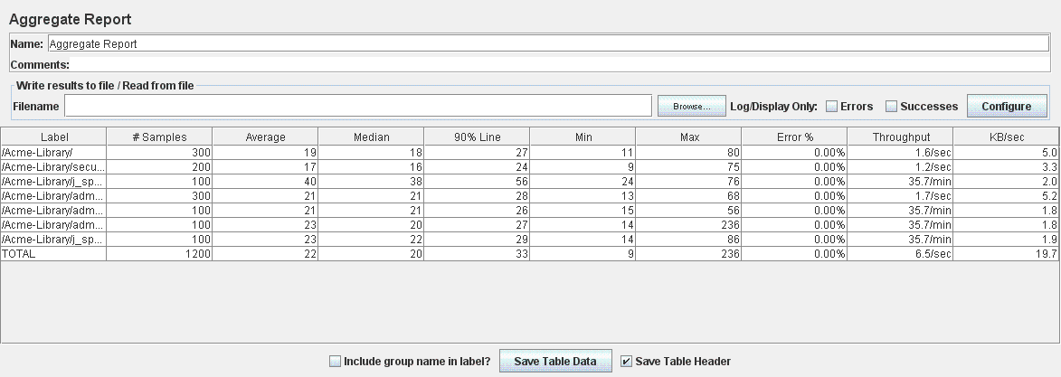

Graph Result

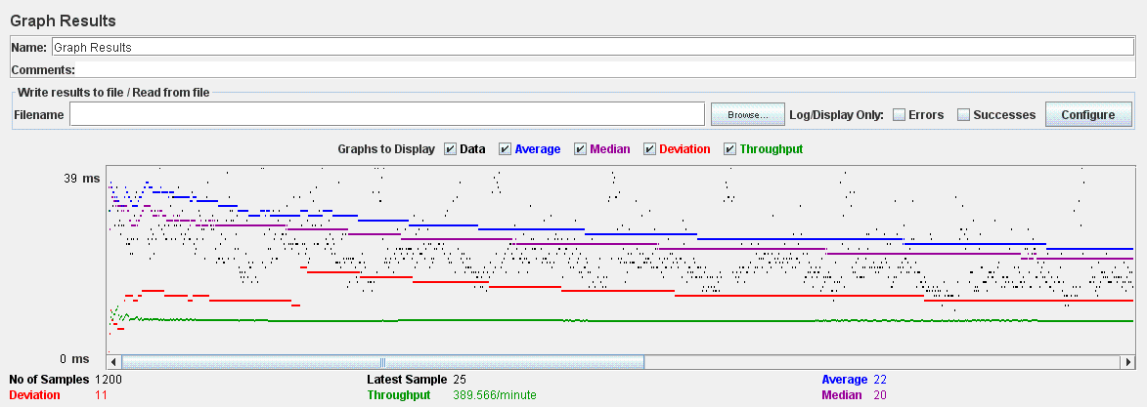

# UC35.7 Add Negative Word test

Aggregate Report

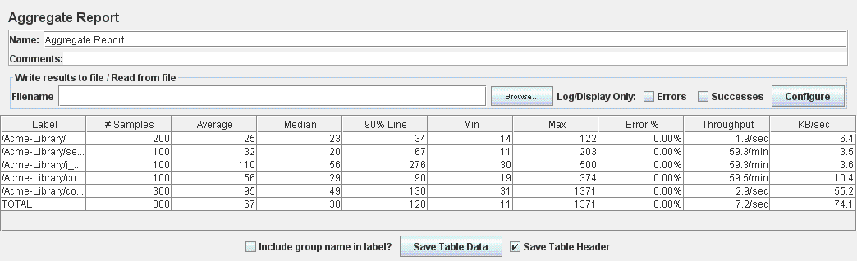

Graph Result

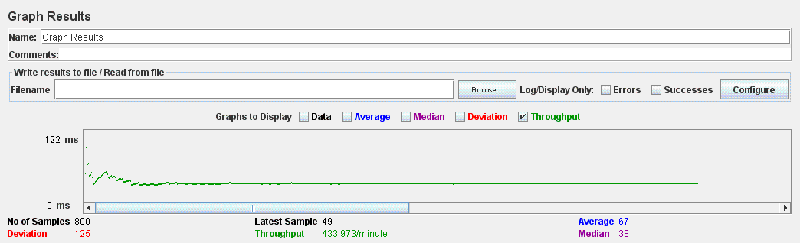

# UC35.7 Add Positive Word test

Aggregate Report

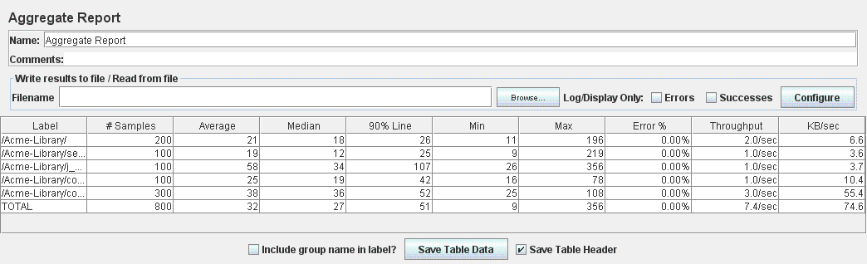

Graph Result

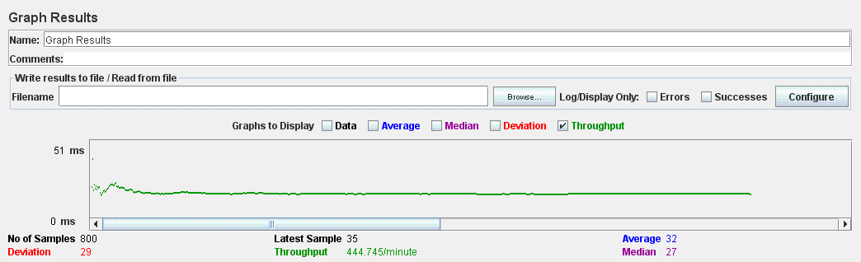

# UC35.7 Delete Positive Word test

Aggregate Report

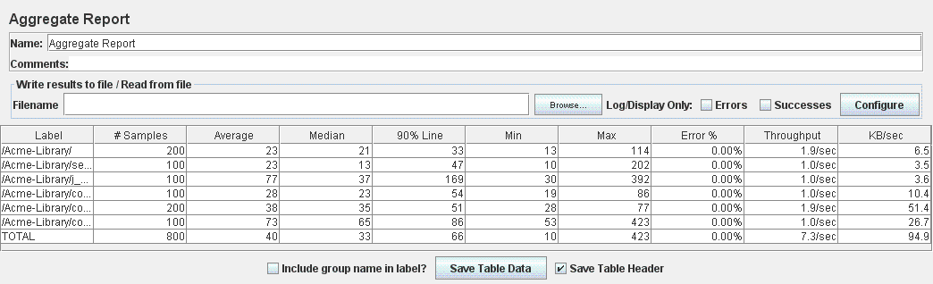

Graph Result

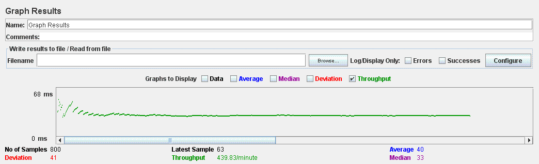

# UC35.7 Delete Negative Word test

Aggregate Report

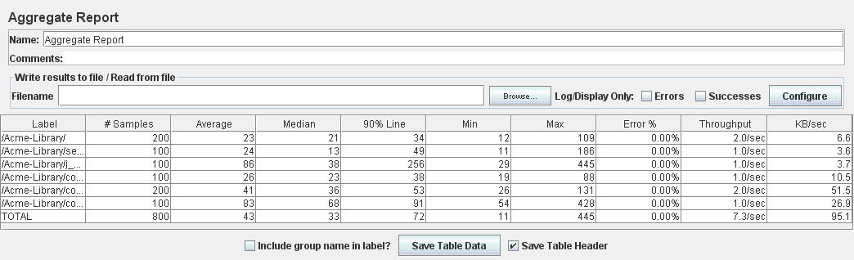

Graph Result

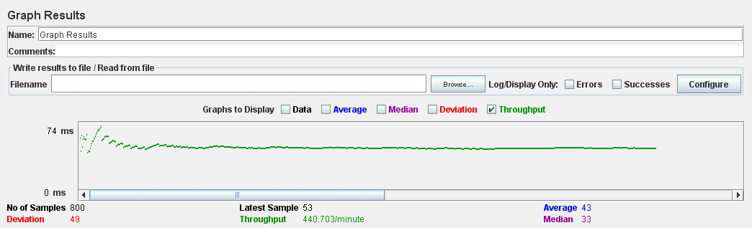

# UC35.8 Deactivate Sponsorships test

Aggregate Report

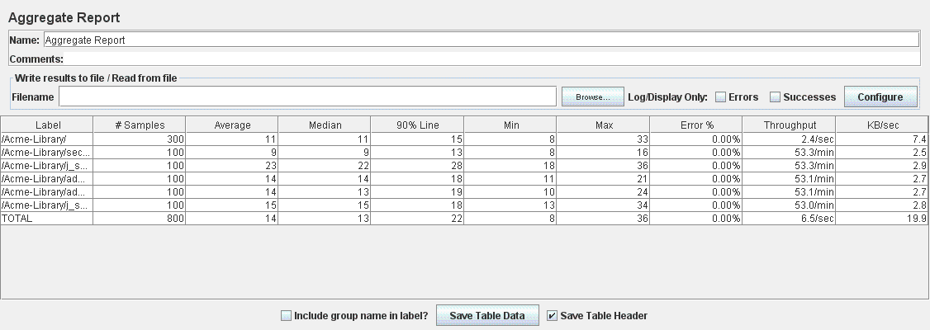

Graph Result

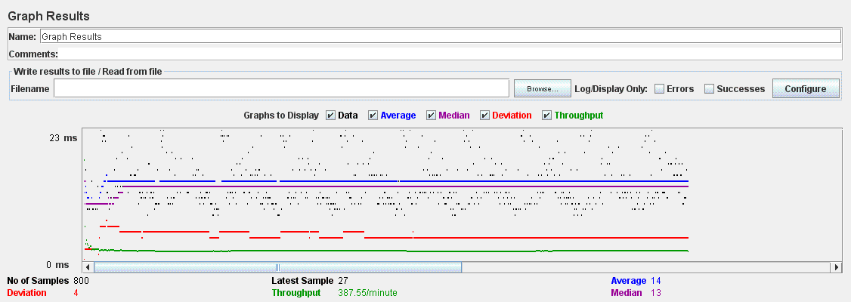

# UC35.9 Delete Inactive Books test

Aggregate Report

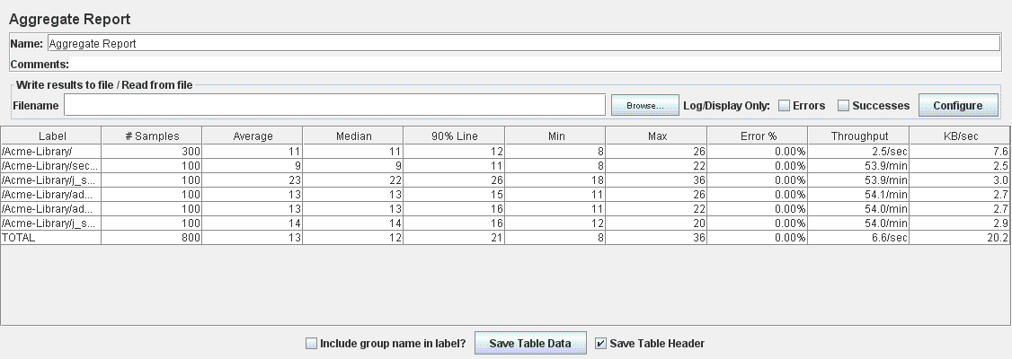

Graph Result

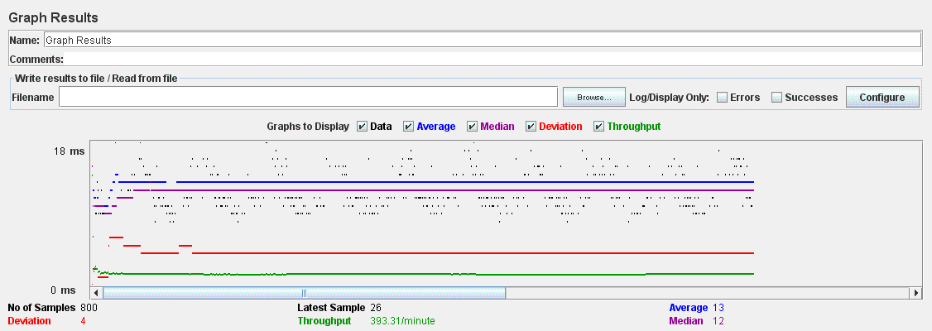

# UC35.10 Calculate Spam test

Aggregate Report

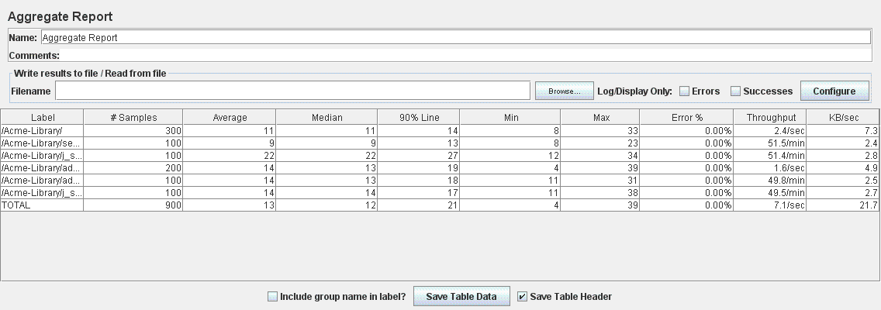

Graph Result

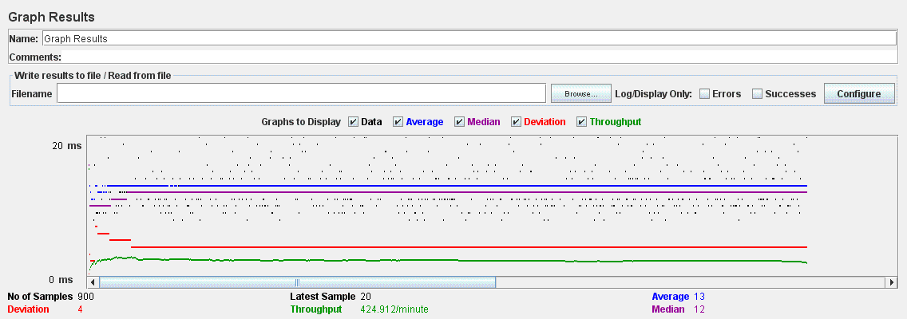

# UC35.13 DashBoard test

Aggregate Report

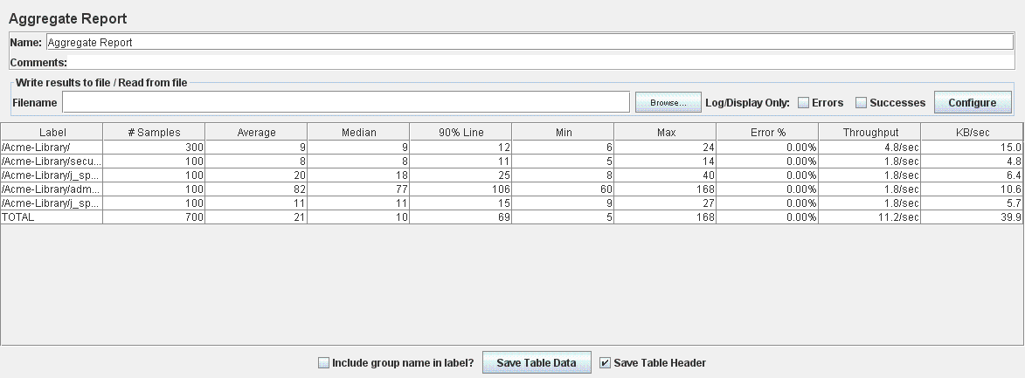

Graph Result

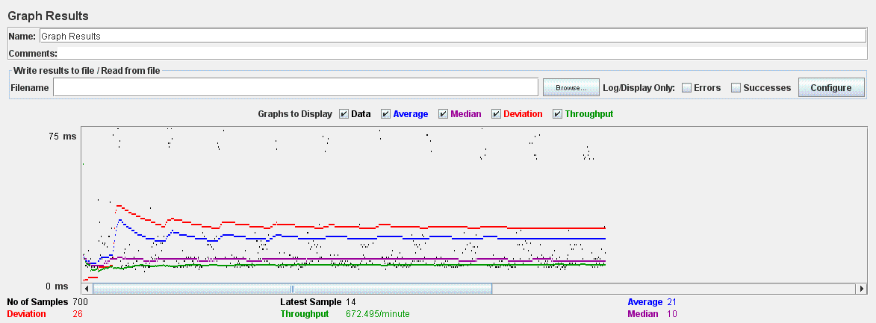

# UC35.11 Calculate Score test

Aggregate Report

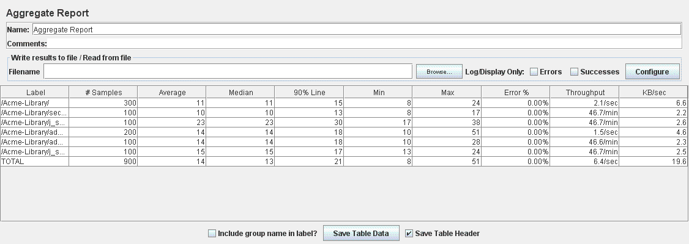

Graph Result

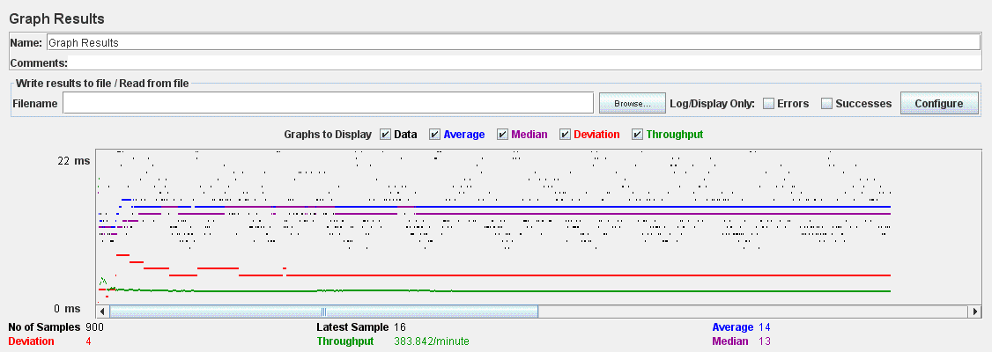

# Performance Analysis

All tests where performed with 10 users and 10 loops and the system behaved properly. Nevertheless we tried to run some tests with 10 users 100 loops, we didn’t find any error percentage in those tests but they were taking much more time and the 90% Line metric was higher probably because of the limitations of the VM.